Taipan Calibration Data Set
Information Processing and Data Analysis
Student Worksheet

This document and its accompanying Excel workbook provide the opportunity to process and analyse authentic scientific data created at ANSTO.
The data was created in order to calibrate one of 14 neutron instruments that are used to study the fundamental properties of various materials.
Students will use their knowledge and understanding acquired from school studies, and from the ideas offered in these documents, to calibrate the position of the sample relative to the TAIPAN neutron instrument.
This dataset is offered primarily to Stage 6 students of Physics and Mathematics.

Contents
Background 3
How TAIPAN is used 3
Aim: 8
STEP 1 9
A: Determine the centre of the circle, approximately. 9
B: Calculate the radius for each scan point 10
C: Determine the deviation (error) of each radii from the average radius. 11
D: Perform a “least squares fit” to find the accurate definition of the circle 12
STEP 2 14
A: Calculate the incremental distance moved by the sample between each position of the 99 positions using the Faro laser data. 14
B: Calculate the incremental angle in degrees moved each step using the Faro data. 15
STEP 3 16
STEP 4 17

Background
ANSTO has its main campus on New Illawarra Road in Lucas Heights, which is a suburb south of Sydney CBD.
ANSTO operates OPAL, which is the only nuclear reactor in Australia. OPAL produces neutrons of different energies and operates for 300 days every year. One significant use of these neutrons is to feed 14 different scientific instruments that provide a world class neutron scattering facility, used by many Australian and international scientists each year. One of these instruments is called TAIPAN.

How TAIPAN is used
Researchers use neutrons from the OPAL reactor for diffraction experiments. While neutrons are particles, they also have wave-like properties. If you direct a beam of neutrons at a sample, some neutrons will interact with the nuclei of that sample and scatter (diffract). The pattern of diffracted neutrons can tell scientists about the crystal structure, or the arrangement of atoms, inside the sample material.
Neutrons coming from the reactor have a wide range of wavelengths. Scientists select neutrons with a very narrow range of wavelengths to optimise their diffraction experiments. In TAIPAN, neutrons pass through a monochromator, which spreads the neutrons out into space in a similar way that a prism spreads a beam of white light into its different colours or wavelengths. Scientists position the sample at a specific angle from the monochromator between 40 and 50 degrees so as to expose it to their chosen neutron wavelength (Figure a). This angle is called the wavelength angle (M2). A motor drives the sample to the correct position and wavelength angle for the experiment.
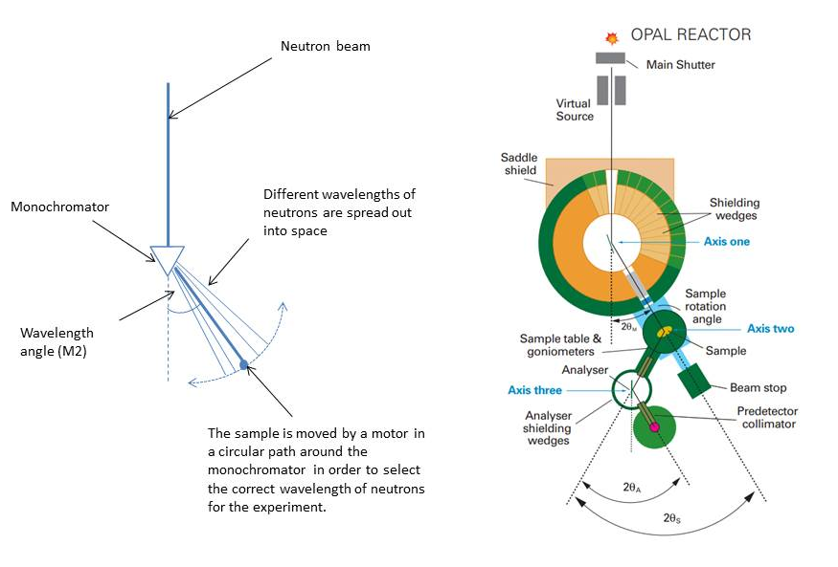
b)
a)
- A diagram showing how a monochromator spreads an incoming neutron beam into different wavelengths.
- A technical diagram of TAIPAN, a neutron diffraction instrument at ANSTO. The monochromator is at axis one and the sample is at axis two.
As the scientists rely on the wavelength angle of the sample to determine the wavelength of neutrons used in their experiment, it is crucial that they can measure the wavelength angle with very high accuracy (±0.005 degrees).
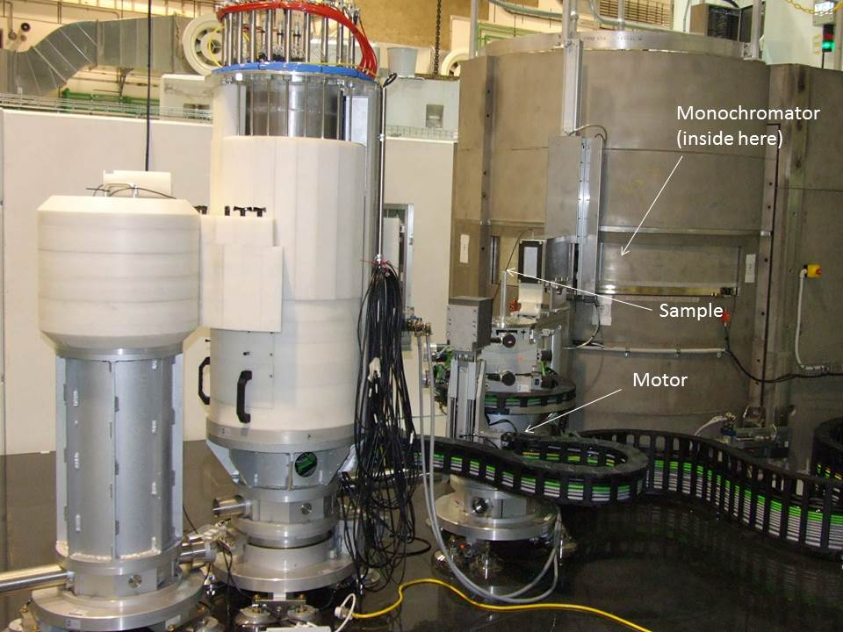
A photo of TAIPAN, one of the neutron diffractometers at ANSTO, showing the locations of the monochromator, sample and motor.
To measure the wavelength angle of the sample, scientists use a rotary encoder, which is a simple, inexpensive and easy-to-use device. In these notes, we refer to this device as “Rotary”. The rotary encoder sits on top of the motor and calculates the wavelength angle using motor shaft changes, gear box ratios and rack and pinion gear ratios.
The rotary encoder is periodically calibrated to ensure it is measuring the wavelength angle accurately. To do this, scientists set up a measurement trial using a much more expensive instrument called a Faro laser tracker, which is labour intensive and requires many hours of set up. The Faro laser tracker determines the position of the sample in space, in the format of X and Y distance data to the sample in millimetres. X and Y coordinates from Faro can be converted into wavelength angles using trigonometry.
In this experiment we set up the laser tracker, Faro, in a random location to measure the distance to the sample when the sample is placed with a nominal wavelength angle of approximately 40 degrees. The sample is then gradually moved along the arc of a circle, with the monochromators at the centre, in 98 increments to a wavelength angle of approximately 50 degrees. X and Y distance data from the Faro laser tracker (Column B and C in the spreadsheet) and the wavelength angle measured by the rotary encoder (Column D) were recorded for each of the 99 scan points along the arc of the circle (Column A).
Your task is to:
- Calculate the true wavelength angle of the sample at each of the 98 increments using the Faro data and compare this with the wavelength angle measured by Rotary.
- Calculate the difference (error) between the true Faro value and the measured Rotary value for the wavelength angle at each scan point. An error of ±0.005 degrees is tolerated.
- There is a problem with the rotary encoder at a particular wavelength angle. Analyse the error values at each wavelength angle to determine where the issue arises so that the TAIPAN technical staff can repair it.
For full information about TAIPAN, which is a triple axis spectrometer, read these web pages: https://www.ansto.gov.au/user-access/instruments/neutron-scattering-instruments/taipan-thermal-triple-axis-spectrometer

Read the articles listed below. Use the information presented in these articles and any other appropriate sources you gather to assist you in answering the following questions.

NSW Department of Education. (2019). Resources for science instruction – Evaluating data. https://education.nsw.gov.au/teaching-and-learning/curriculum/key-learning-areas/science/stage-6/resources
Victoria Curriculum and Assessment Authority. (2019). Experimental uncertainty and error. https://www.vcaa.vic.edu.au/curriculum/vce/vce-study-designs/biology/advice-for-teachers/Pages/MeasurementInScienceExperimentalUncertaintyandError.aspx

Carlson, G.A. (2002). Experimental error and uncertainty. Rochester University. http://www2.ece.rochester.edu/courses/ECE111/error_uncertainty.pdf

NIST Sematech. (Unknown). Instrument calibration over a regime. Engineering Statistics Handbook. https://www.itl.nist.gov/div898/handbook/mpc/section3/mpc36.htm

- Measurement errors refer to the difference between the measured value and the true reference value. There are always errors in any measurement. Scientists do their best to categorize errors and quantify any uncertainty in measurements they make. Measurement errors are generally classified as either random or systematic.
Define random and systematic error and give an example of each:-
………………………………………………………………………………………………………………………………………………………………………………………………………………………………………………………………………………………………………………………………………………………………………………………………………………………………
………………………………………………………………………………………………………………………………………………………………………………………………………………………………………………………………………………………………………………………………………………………………………………………………………………………………

- Why is it important for scientists to know the type of error when they report on experiments?
…………………………………………………………………………………………………………………………………………………………………………………………………………………………………………………………………………………………………………………………
…………………………………………………………………………………………………………………………………………………………………………………………………………………………………………………………………………………………………………………………

- What is calibration?
………………………………………………………………………………………………………………………………………………………………………………………………………………………………………………………………………………………………………………………………………………………………………………………………………………………………………………………………………………………

- What sort of equipment needs to be calibrated?
………………………………………………………………………………………………………………………………………………………………………………………………………………………………………………………………………………………………………………………………………………………………………………………………………………………………………………………………………………………

- Why is calibration necessary?
………………………………………………………………………………………………………………………………………………………………………………………………………………………………………………………………………………………………………………………………………………………………………………………………………………………………………………………………………………………
…………………………………………………………………………………………………………………………………………………………………………………………………………………………………………………………………………………………………………………………

- Describe how, in general, calibration is performed – what are the basic steps essential for effective calibration?
………………………………………………………………………………………………………………………………………………………………………………………………………………………………………………………………………………………………………………………………………………………………………………………………………………………………………………………………………………………
………………………………………………………………………………………………………………………………………………………………………………………………………………………………………………………………………………………………………………………………………………………………………………………………………………………………………………………………………………………
…………………………………………………………………………………………………………………………………………………………………………………………………………………………………………………………………………………………………………………………

Aim:
- To determine how well the less expensive rotary encoder, Rotary, encodes for the angle compared to the very accurate and expensive laser tracker, Faro.

- To determine the location of a ‘sticking point’ in between 40 and 50 degrees where we have noticed large errors and non-sensible results in the data

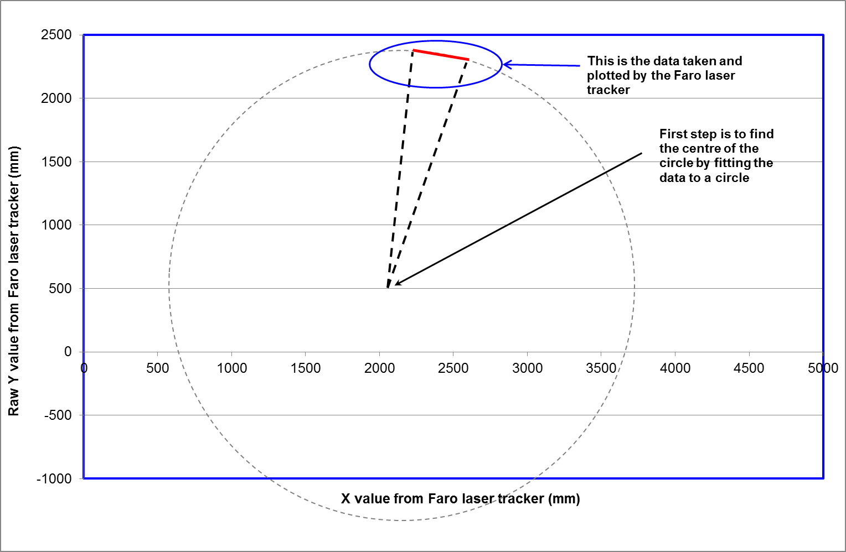

Your task is to compare the angular position information from both Faro and Rotary to determine the inaccuracy of the Rotary instrument at each position.
Faro only measures linear position, in millimetres, as shown in the above diagram. You will need to convert linear position to rotational position (angle) in order to compare the readings between the two instruments.
Your first step is to find the centre of the circle and to then determine the radius of the circle. You will then perform a least squares fit to find the accurate definition of the circle.
This will enable you to convert the Faro X,Y readings that show the linear movement between each position into angular position of the sample, to enable you to compare this data with the angular position provided by Rotary.

STEP 1

To define the circle that the sample carrier traverses by determining the most accurate definition of the radius, R, of the circle that the sample carrier moves along (in an arc of 10º) and also the XY position of the centre of the circle that the sample traverses.

A: Determine the centre of the circle, approximately.

To do this you will use the circle theorem stated below:
The perpendicular bisector of a chord is a line that crosses the chord at 90° (perpendicular) and cuts it in half (bisector). The perpendicular bisector of a chord passes through the centre of the circle.
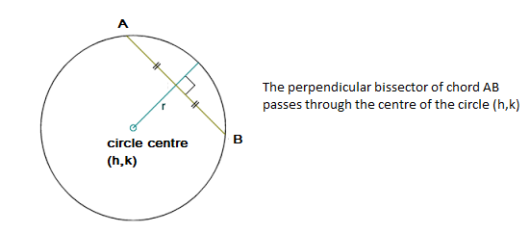
- Select the 3 scan points 1, 49 and 99 and use the Faro X,Y values of these scan points in the following steps.

- Find the gradient of the chord through scan points 1 and 49. Then using the formula below, find the gradient of the perpendicular bisector of this chord.
$$gradient of chord,m=\frac{y_{2}-y_{1}}{x_{2}-x_{1}}$$

$$gradient of perpendicular bisector, M= -\frac{1}{m}$$

- Find the midpoint of the chord through scan points 1 and 49.
$$x_{m}=\frac{x_{1}+x_{2}}{2}, y_{m}=\frac{y_{1}+y_{2}}{2}$$

- Use the midpoint and the gradient of the perpendicular bisector of the chord to find its equation.
$y-y_{m}$= $M(x-x_{m})$

- Repeat the above steps for scan points 49 and 99.

- Solve the two simultaneous equations you have determined for the perpendicular bisectors to find their point of intersection. This is the centre of the circle. State your values for h and k (the coordinates of the centre of the circle) to 3 decimal places.

- Place the values only for h and k at the bottom of the x position (column B) and y position (column C) columns respectively, that is in cells B104 and C104.

[Answer: x value of centre, h = 2008.105 (to 3 dp), y value of centre, k = 252.468 (to 3 dp)]
When using the h and k values for the centre of the circle in further calculations you will need to keep the cell reference constant. To do this, you need to add the $ symbol to the cell reference (eg $B$104) by highlighting the cell reference in the formula and pressing the F4 key.

B: Calculate the radius for each scan point
Using the equation of a circle shown below, calculate the radius for each of the scan points 1 to 99 in the spreadsheet.
(x – h)² + (y – k)² = r²
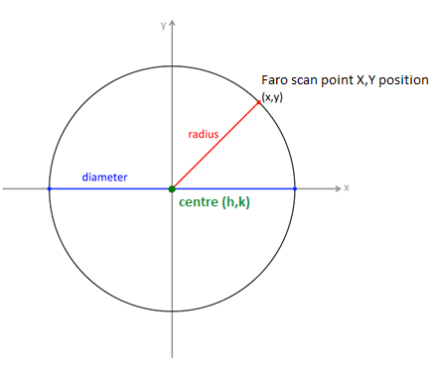

Hint: Enter the formula below into the first cell of the next column (column E)
=SQRT((B4-$B$104)^2+(C4-$C$104)^2)
where SQRT = square root
^2 = squares the bracketed value
SBS104 = the cell for h value (x value) of the circle centre
$C$104 = the cell for k value (y value) of the circle centre
Click on this cell (E3) so that it is highlighted, and hold your cursor over the bottom right hand side of the highlighted cell. Left click and drag the cursor down the column to the cell for scan point 99. This action will fill the formula down the column. Label this column Radius.

C: Calculate the difference between the average, and the actual, radius for each point
- Determine the average radius of the scan points.

Hint: Place the cursor in cell E104, where you wish to have the mean (average) appear, and click the mouse button.

Select Insert Function (f_{x}) from the FORMULAS tab. A dialog box will appear. Select AVERAGE from the Statistical category and click OK.

Enter the cell range by moving the cursor to the first radius you wish to use (cell E4) and clicking and dragging the cursor down to the last radius (cell E102).

Once you have entered the range, click on OK at the bottom of the dialog box. The mean (average) will appear in the cell E104.

- In the next column (column F), subtract each value in the “Radius” column (column E) from the average radius. Don’t forget to keep the cell reference constant for the average radius by adding the $ symbol to the cell reference. Add the column heading ‘deviation’.
Hint: Enter the formula =($E$104-E4) into cell F4 and fill this formula down the column.

D: Perform a “least squares fit” to find the best definition of the circle
- In column G, square the deviation values. Use the column heading ‘squared deviation’.

Hint: Enter the formula =(F4)^2 into cell G4 and fill this formula down the column. Format the numbers in the cells of this column to 3 decimal places.

- Sum the squared deviation values.

Hint: In cell G104, enter =SUM(G4:G102) into cell G104

- To get the most accurate values for $(h, k)$, the circle centre, use the add-in Excel tool called SOLVER.
To load the solver add-in in Excel:
- In Excel 2010 and later, go to File > Options. ...
- Click Add-Ins, and then in the Excel Options dialog box, select Add-ins.
- Click Go.
- In the Add-Ins available box, select the Solver Add-in check box, and then click OK. ...
- After you load the Solver Add-in, the Solver command is available in the Analysis group on the Data tab.

(Solver will allow you to determine the values of (h, k) that minimise the sum of the deviation values. This is called the least squares method and is frequently used by scientists as it shows if there is a linear relationship between two variables: in other words, it can reveal some systematic errors.)

- Go to the Data tab and click Solver. The following window will open:
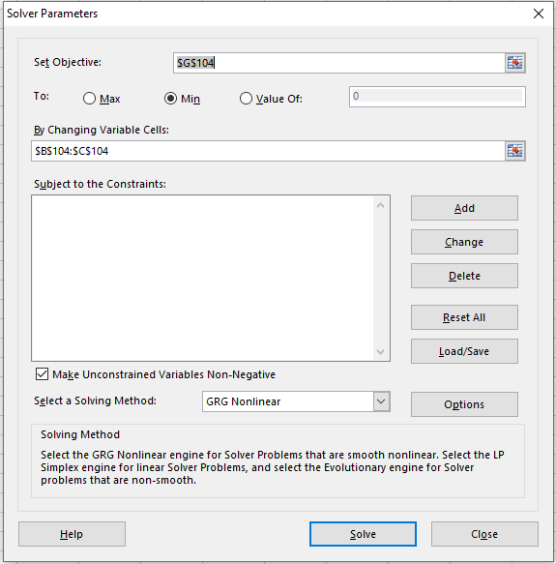
Your Set Objective is to minimise the sum of squared deviations, so select the cell where you have entered this value, that is select cell G104 and choose Min.
Your Variable Cells are the values you have for (h, k) so select the two cells where you have these values only entered, that is click on cell B104 and drag to C104.
Select the solving method GRG Nonlinear. Click “Solve”.
You now have the most accurate definition of the circle that the sample moves along: the centre of the circle as determined by Faro, and its radius.
These are the values you will use from now on to calibrate Rotary.
- A “least squares fit” is used quite frequently in scientific measurement. What is the advantage of using this type of regression analysis?
………………………………………………………………………………………………………………………………………………………………………………………………………………………………………………………………………………………………………………………………………………………………………………………………………………………………………………………………………………………
…………………………………………………………………………………………………………………………………………………………………………………………………………………………………………………………………………………………………………………………

The Excel add-in routine called “Solver” calculates the average radius and the sum of the squares of errors, for a given position of circle centre. It then changes the centre position and re-calculates the sum of the squares of errors. It repeats this process many times until it finds the circle centre position which produces the lowest sum of squares of errors: the “least squares fit”.

STEP 2
To convert the Faro X,Y readings that show the linear movement between each position into angular position of the sample.

A: Calculate the incremental distance moved by the sample between each position of the 99 positions using the Faro laser data.
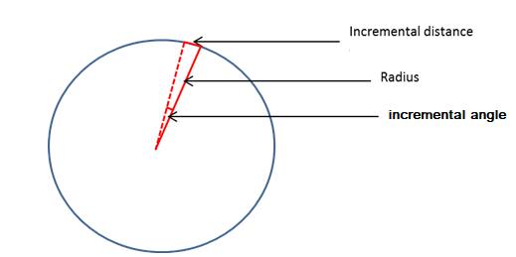
For column H, add the heading ‘incremental distance from “Faro” (mm)’. Enter 0 mm for scan point 1, that is enter 0 in cell H4.
Use Pythagoras’ theorem below and the X and Y Faro data points (columns B and C respectively) to calculate the incremental distance between each of the scan points.
$$r=\sqrt{{\left(x_{1}-x_{2}\right)}^{2}+{\left(y_{1}-y_{2}\right)}^{2}}$$

Hint: enter the formula =SQRT((B5-B4)^2+(C5-C4)^2) into cell H5 and press enter.
Fill this formula down the column.
Format numbers to 3 decimal places.

- Do you expect these incremental distances to be the same or different? Give a reason for your answer.
………………………………………………………………………………………………………………………………………………………………………………………………………………………………………………………………………………………………………………………………………………………………………………………………………………………………………………………………………………………
…………………………………………………………………………………………………………………………………………………………………………………………………………………………………………………………………………………………………………………………

B: Calculate the incremental angle in degrees moved each step using the Faro data.
Using the radius of the circle which you found in step 1 and the distance moved per increment in step 2A, you can now calculate the incremental angle moved for each step.
$$tanθ=incremental distance/radius$$
Enter your first value as 0 degrees in the cell I4.
Excel calculates tan⁻¹$θ$ (ATAN) in radians, so you will need to convert these values to degrees using the formula
$$degrees=radians × \frac{180}{π}$$

Hint: enter =ATAN(H5/$E$104)*180/PI() in cell I5.
Fill this formula down the column.
Format numbers to 3 decimal places.
For column I, add the heading ‘incremental angle from “Faro” (degrees)’.

STEP 3
To compare the reading from Rotary with your computed angular Faro reading for each position.

- Determine the incremental angle from “Rotary” in degrees by finding the difference in angular position from “Rotary” (column D) for each of the successive scan points.

Hint: Enter 0 in the cell J4.
In cell J5, enter the formula =D5-D4
Fill this formula down the column.
Format numbers to 3 decimal places.
For column J, add the heading ‘incremental angle from “Rotary” (degrees)’.

- In the next column (column K), determine the deviation (error) of each incremental angle from “Rotary” and the incremental angle from “Faro” by subtracting the value in column I from the value in column J for each scan point.

Hint: in cell K4, enter the formula =J4-I4.
Fill this formula down the column.
For column K, add the heading ‘error value’.

The values obtained by the Rotary encoder are different to the values obtained by the laser tracker Faro. The difference between the values is known as the “error value”. A small error value is acceptable to scientists.

- Do you think that plotting the error value of angular position would be helpful to understand the results? Give a reason for your answer.

………………………………………………………………………………………………………………………………………………………………………………………………………………………………………………………………………………………………………………………………………………………………………………………………………………………………………………………………………………………
…………………………………………………………………………………………………………………………………………………………………………………………………………………………………………………………………………………………………………………………

STEP 4
To identify the range of positions where the error values seem unduly large.
Construct a scatter graph with smooth lines to show the error value (column K on y axis) versus the angular position from “Rotary” (column D on x axis).
Label your axes and include units. Give your graph a title.

Hint: You can use the following steps to create your chart:

- Highlight all the data in column D ‘angular position from “Rotary”’, hold down the control button and highlight all the data in column K ‘error value’. Do not include the column headings.
- On the Insert tab, in the Charts group, click the Scatter symbol.

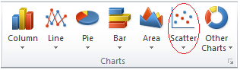
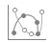
- Click scatter graph with smooth lines.

- To change the data range of the x axis, right-click the x axis value increments and, in the dialog box that opens, click Format Axis to fix minimum and maximum range values. Choose a range of 40.0 – 50.0 for angular position from “Rotary” on x axis.

- Add axes titles and chart title (For Excel 2013, click on your scatter graph and then click on the Design in Chart Tools to find Add Chart Elements. Click here to add axes titles)

An error not more than ±0.005 degrees can be tolerated. So, if the readings from the two instruments are within this error range, then Rotary can be used to determine the position of Taipan reliably.

Add the horizontal benchmark lines $y=+0.005$ and $y=-0.005$ by adding new data series in the Excel chart. Make these lines red. These lines show which data are within the tolerable error of the instrument.

Hint:
- Add the Benchmark line columns by entering 0.005 in cell L4, and -0.005 in cell M4. Fill these values down each of the columns respectively.

- For column L, add the heading ‘maximum error value’, and for column M add the heading ‘minimum error value’.

- Right click in the plot area of the chart and choose select data.

- The Select Data Source dialog box appears. In the dialog box, select Add.

- In the second dialog box that opens type in the series name ‘maximum error value’.

- Click in the Series X values: then highlight all the data in column D ‘angular position from “Rotary”.

- Click in the Series Y values:, delete {1} and highlight all the data in column L ‘maximum error value’. Click OK.

- Now the maximum error value line is added to the chart. Right-click the maximum error value line, and select Change Series Chart Type from the context menu.

- In the Change Chart Type dialog box, specify the chart type of the maximum error value line as Scatter with Straight Line, and click the OK button.

- Repeat steps 3 to 10 to add the minimum error value line to the graph.

- At what positions are the errors unacceptable?
………………………………………………………………………………………………………………………………………………………………………………………………………………………………………………………………………………………………………………………………………………………………………………………………………………………………………………………………………………………

- Do you think these errors are random or systematic? Explain your answer.
………………………………………………………………………………………………………………………………………………………………………………………………………………………………………………………………………………………………………………………………………………………………………………………………………………………………………………………………………………………
…………………………………………………………………………………………………………………………………………………………………………………………………………………………………………………………………………………………………………………………

- Give two examples of random errors that could affect these measurements.
………………………………………………………………………………………………………………………………………………………………………………………………………………………………………………………………………………………………………………………………………………………………………………………………………………………………………………………………………………………
……………………………………………………………………………………………………………………………………………………………

- Think about the reality of these measurements. Can you postulate an explanation for the large errors that are revealed on the graph?
………………………………………………………………………………………………………………………………………………………………………………………………………………………………………………………………………………………………………………………………………………………………………………………………………………………………………………………………………………………
…………………………………………………………………………………………………………………………………………………………………………………………………………………………………………………………………………………………………………………………

- Imagine that you are the scientist responsible for using Taipan to make accurate measurements of a material. What would be your main concern upon seeing this graph? What would you like to happen next?
………………………………………………………………………………………………………………………………………………………………………………………………………………………………………………………………………………………………………………………………………………………………………………………………………………………………………………………………………………………
…………………………………………………………………………………………………………………………………………………………………………………………………………………………………………………………………………………………………………………………

